Báo cáo tuần 6

Họ và tên: Nguyễn Gia Lộc MSSV: 20194607

1. Import the existing project into the workspace of Eclipse

2. Creating the Book class

import java.util.*;

public class Book extends Media{

    private List<String> authors = new ArrayList<String>();

    public List<String> getAuthors() {

        return this.authors;

    }

    public void setAuthors(List<String> authors) {

        this.authors = authors;

    }

    public void addAuthor(String authorName){

        authors.add(authorName);

    }

    public void removeAuthor(String authorName){

        authors.remove(authors.size()-1);

    }

    public Book(String title, String category, float cost, List<String> authors) {

        super();

        this.title = title;

        this.category = category;

        this.cost = cost;

        this.authors = authors;

    }

}

3. Creating the Media class

public class Media {

    protected String title;

    protected String category;

    protected double cost;

    public String getTitle() {

        return this.title;

    }

    public void setTitle(String title) {

        this.title = title;

    }

    public String getCategory() {

        return this.category;

    }

    public void setCategory(String category) {

        this.category = category;

    }

    public double getCost() {

        return this.cost;

    }

    public void setCost(float cost) {

        this.cost = cost;

    }

}

4. Update the Order class to work with Media

import java.util.*;

import javax.sound.sampled.SourceDataLine;

public class Order {

    public static final int MAX_NUMBER_ORDERED = 10;

    ArrayList<Media> itemsOrdered = new ArrayList<Media>();

    public void addMedia(Media media) {

        if (itemsOrdered.size() < MAX_NUMBER_ORDERED) {

            itemsOrdered.add(media);

            System.out.println("The media has been added");

            System.out.println(itemsOrdered.size());

        } else {

            System.out.println("ERROR!!! Vuot qua so luong MAX_NUMBER_ORDERED");

            System.out.println("Can't add media have title \"" + media.getTitle() + "\" in Order");

        }

    }

    public void removeMedia(Media media) {

        if (itemsOrdered.contains(media)) {

            itemsOrdered.remove(media);

        } else

            System.out.println("List don't have this item");

    }

    public void removeMediaById(int ID) {

        if (ID<itemsOrdered.size()) {

            itemsOrdered.remove(itemsOrdered.remove(ID));

        } else

            System.out.println("List don't have this item");

    }

    public double totalCost() {

        double total = 0f;

        for (Media media : itemsOrdered) {

            total += media.getCost();

        }

        return total;

    }

}

5. Create a complete console application in the Aims class

import java.util.*;

import java.util.Scanner;

public class Aims {

    public static void showMenu() {

        System.out.println("Order Management Application");

        System.out.println("------------------------");

        System.out.println("1.Create new order");

        System.out.println("2.Add item to the order");

        System.out.println("3.Delete item by id");

        System.out.println("4.Display the items list of order");

        System.out.println("0.Exit");

        System.out.println("------------------------");

        System.out.println("Please choose a number 0-1-2-3-4");

    }

    public static void main(String args[]) {

        Order anOrder = new Order();

        int dem = 0;

        while (true) {

            System.out.println("\n\n");

            showMenu();

            Scanner myObj = new Scanner(System.in);

            Integer myChoose = myObj.nextInt();

            if (myChoose == 1) {

                System.out.println("An order is created");

            } else if (myChoose == 2) {

                System.out.println("DVD || BOOK ???");

                Scanner myObj1 = new Scanner(System.in);

                String myChoose1 = myObj1.nextLine();

                if (myChoose1.toUpperCase().equals("BOOK")) {

                    List<String> list = new ArrayList<String>();

                    list.add("Nguyen Gia Loc");

                    list.add("Ngo Thua An");

                    Book book1 = new Book(dem, "Tay du ki", "Tieu thuyet", 100.3f, list);

                    dem++;

                    anOrder.addMedia(book1);

                } else if (myChoose1.toUpperCase().equals("DVD")) {

                    DigitalVideoDisc disk1 = new DigitalVideoDisc(dem, "Vien Da Nho", "Music", 100.44f, "Hai Bang",

                            150);

                    dem++;

                    anOrder.addMedia(disk1);

                } else

                    System.out.println("Can't add this item in Order");

            } else if (myChoose == 3) {

                System.out.println("ID of item want to remove:");

                Scanner myObj2 = new Scanner(System.in);

                Integer ID = myObj2.nextInt();

                anOrder.removeMediaById(ID);

            } else if (myChoose == 4) {

                for (Media item : anOrder.itemsOrdered) {

                    System.out.println("ID:" + item.getId() + "\t" + "Title:" + item.getTitle() + "\t" + "Cost:"

                            + item.getCost() + "\t" + "Category:" + item.getCategory());

                }

            } else

                break;

        }

    }

}

Chạy chương trình

Tạo Order

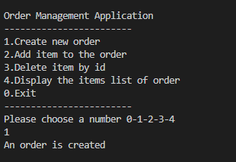

Thêm media dvd vào order

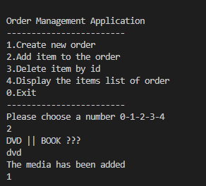

Thêm media book vào order

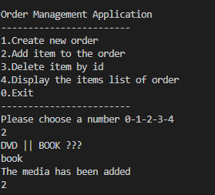

Duyệt qua order list

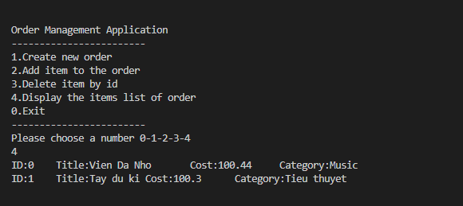

Id của item muốn xóa khỏi list

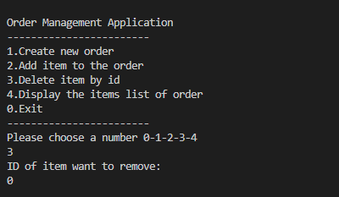

* Kết quả

